Statistical operations
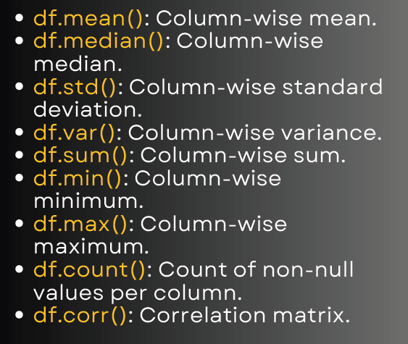

Example DataFrame:
import pandas as pd
data = {
'A': [10, 20, 30, 40, 50],
'B': [5, 10, 15, 20, 25],
'C': [2, 4, 6, 8, 10]
}
df = pd.DataFrame(data)
print(df)
Output:
A B C
0 10 5 2
1 20 10 4
2 30 15 6
3 40 20 8
4 50 25 10

Statistical Functions
1.Mean (average value per column)
print(df.mean())

Output:
A 30.0
B 15.0
C 6.0

2.Median (middle value per column)
print(df.median())
Output:
A 30.0
B 15.0
C 6.0

3.Standard Deviation
print(df.std())
Output:
A 15.811
B 7.906
C 3.162

4.Variance
print(df.var())

Output:
A 250.0
B 62.5
C 10.0

5.Sum
print(df.sum())
Output:
A 150
B 75
C 30

6.Minimum
print(df.min())
Output:
A 10
B 5
C 2

7. Maximum
print(df.max())

Output:
A 50
B 25
C 10

8.Count of Non-Null Values
print(df.count())
Output:
A 5
B 5
C 5

9.Correlation Matrix
print(df.corr())
Output:
A B C
A 1.0 1.0 1.0
B 1.0 1.0 1.0
C 1.0 1.0 1.0
Perfect correlation because B and C are multiples of A.)

